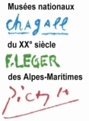
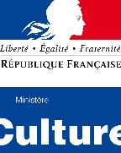
Service des réservations de groupes

Musée national Fernand Léger
Chemin du Val de Pôme
06410 Biot
T 04 93 53 87 28
Visiteguide-mn06@culture.gouv.fr

Musée national Marc Chagall
Avenue Docteur Ménard
06000 Nice
T 04 93 53 87 28
Visiteguide-mn06@culture.gouv.fr

PRE-BOOKING FORM FOR GUIDED TOURS
Personal information
Company / School | Click here
Address | Click here
Name of tour leader | Click here.
Phone number | Click here.
E-mail | Click here.
Date of demand | Cliquez ici pour entrer une date.

Information about my group(s)
Number of group(s) | Click here to enter a number
Number of people (group #1) | Click on the black arrow | Number of attendants
Number of people (group #2) | Click on the black arrow. | Number of attendants
Age / Educational level | Choisissez un élément.

Information about my visit
I choose the museum | Click on the black arrow to select
I suggest a date and time (#1) | Choose a date | Here
I suggest a date and time (#2) | Choose a date | Here
I suggest a date and time (#3) | Choose a date | Here
I suggest a date and time (#4) | Choose a date | Here
I choose the duration | Click on the black arrow
I choose the language | Click on the black arrow
I choose a visit or an activity | Click on the black arrow
Personal request (I complete the space below to add the necessary details to my request
Click here

N.B.
This form must be completed and sent back to : visiteguide-mn06@culture.gouv.fr

You can go on our website for all information (exhibitions, prices, practical information…) : http://musees-nationaux-alpesmaritimes.fr/

